**Practical No:-4**

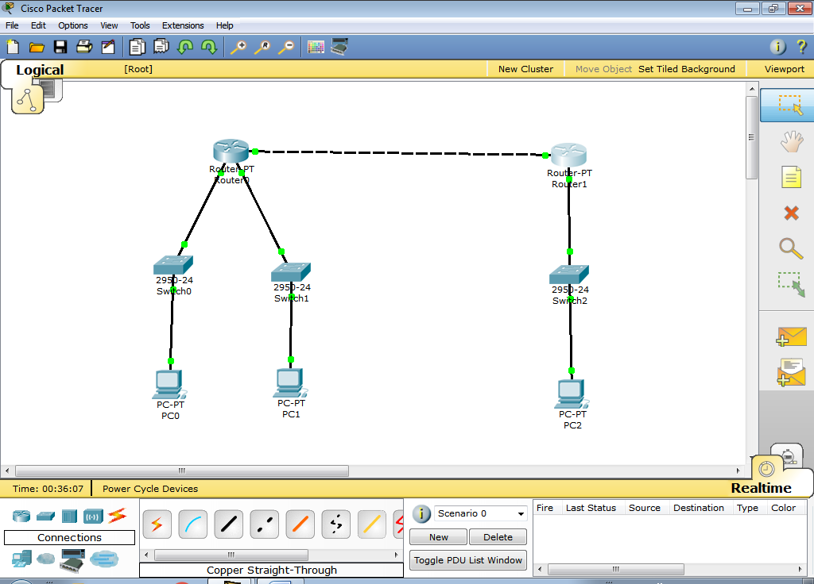

**Configure Router R0:**

Router>en

Router#config t

Enter configuration commands, one per line. End with CNTL/Z.

Router(config)#interface f0/0

Router(config-if)#ip address 10.0.0.1 255.0.0.0

Router(config-if)#no shut

%LINK-5-CHANGED: Interface FastEthernet0/0, changed state to up

Router(config-if)#exit

Router(config)#interface f1/0

Router(config-if)#ip address 20.0.0.1 255.0.0.0

Router(config-if)#no shut

%LINK-5-CHANGED: Interface FastEthernet1/0, changed state to up

%LINEPROTO-5-UPDOWN: Line protocol on Interface FastEthernet1/0, changed state to up

Router(config-if)#exit

Router(config)#interface eth6/0

Router(config-if)#ip address 30.0.0.1 255.0.0.0

Router(config-if)#no shut

%LINK-5-CHANGED: Interface Ethernet6/0, changed state to up

%LINEPROTO-5-UPDOWN: Line protocol on Interface Ethernet6/0, changed state to up

Router(config-if)#exit

**Configure Router R1 :**

Router>en

Router#config t

Enter configuration commands, one per line. End with CNTL/Z.

Router(config)#interface f0/0

Router(config-if)#ip address 10.0.0.2 255.0.0.0

Router(config-if)#no shut

%LINK-5-CHANGED: Interface FastEthernet0/0, changed state to up

%LINEPROTO-5-UPDOWN: Line protocol on Interface FastEthernet0/0, changed state to up

Router(config-if)#exit

Router(config)#interface f1/0

Router(config-if)#ip address 40.0.0.1 255.0.0.0

Router(config-if)#no shut

%LINK-5-CHANGED: Interface FastEthernet1/0, changed state to up

%LINEPROTO-5-UPDOWN: Line protocol on Interface FastEthernet1/0, changed state to up

Router(config-if)#exit

IP Configuration For PC0:

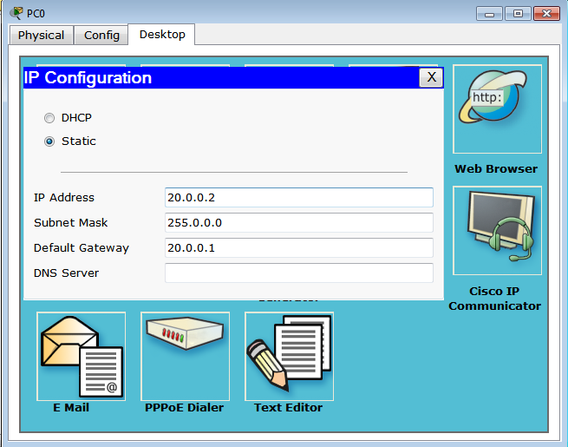

IP Configuration For PC1:

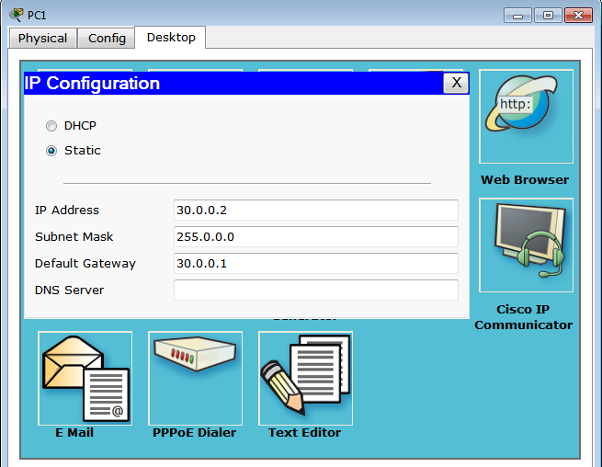

IP Configuration For PC2:

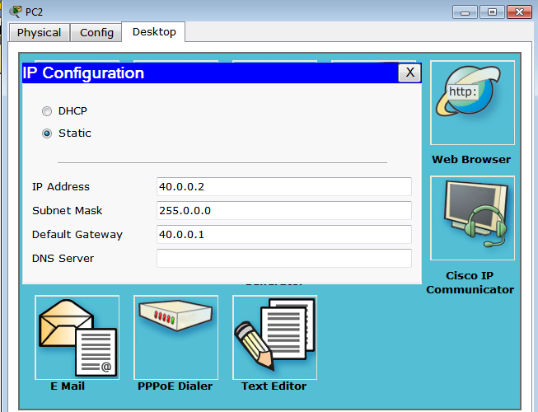

**Configure RIP to Router R0:**

Router>en

Router#config t

Enter configuration commands, one per line. End with CNTL/Z.

Router(config)#router rip

Router(config-router)#network?

network

Router(config-router)#network 10.0.0.0

Router(config-router)#network 20.0.0.0

Router(config-router)#network 30.0.0.0

Router(config-router)#^Z

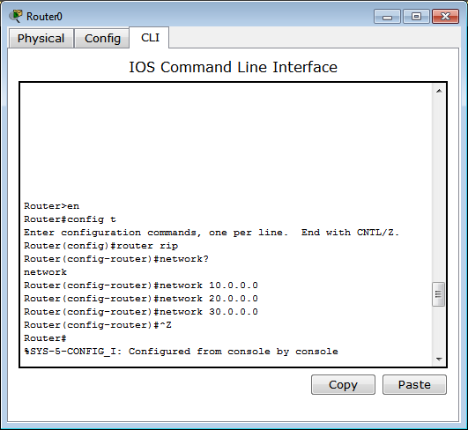

**Configure RIP to Router R1:**

Router>en

Router#config t

Enter configuration commands, one per line. End with CNTL/Z.

Router(config)#router rip

Router(config-router)#network?

network

Router(config-router)#network 10.0.0.0

Router(config-router)#network 40.0.0.0

Router(config-router)#^Z

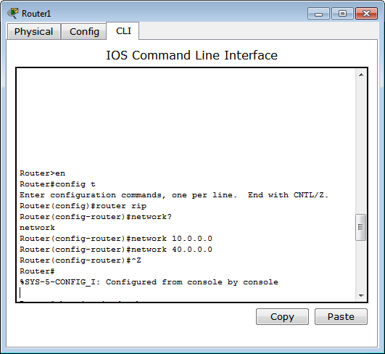

**See Routing Table For Router R0:**

Router#show ip rip database

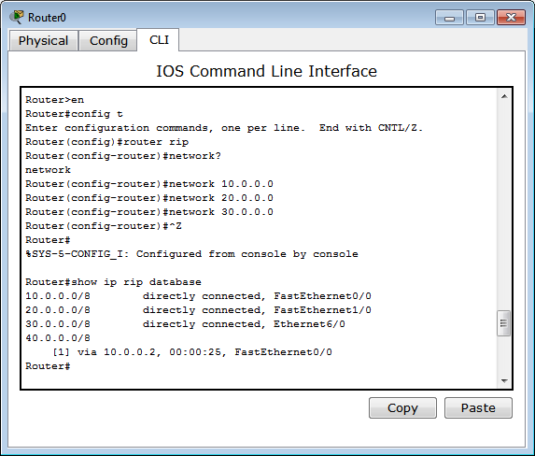

**See Routing Table For Router R1:**

Router#show ip rip database

